*Translation from Romanian into English*

*round stamp applied*

|  |  |  |  |  |
| --- | --- | --- | --- | --- |
|  | Societatea Nationala “Nuclearelectrica” S.A. |  | **ORGANISATION CHART**  valid from *09.03.2020* | **APPROVED**  **PRESIDENT of the BD**  **Iulian Robert TUDORACHE**  *illegible signature* |
|  | **ENDORSED**  **GENERAL MANAGER**  **Cosmin GHITA**  *illegible signature* |

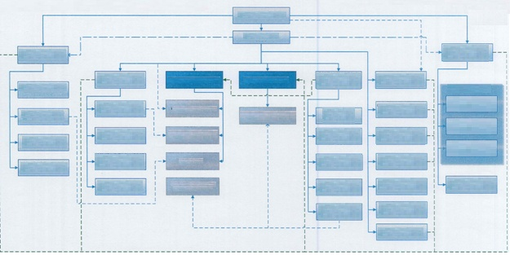

**Financial Division**

FINANCIAL AND BUDGET REPORTING DEPARTMENT

(4/1/3)

NUCLEAR SECURITY AND TECHNICAL SUPPORT DEPARTMENT

(13/2/11)

PHYSICAL PROTECTION AND CLASSIFIED INFORMATION

(11/3/8)

CONFORMITY OFFICE

(1/1/0)

INTERNATIONAL RELATIONS AND EUROPEAN POLICIES

(2/1/1)

GENERAL SECRETARY

(3/1/2)

ELECTRIC POWER TRANSACTIONS DIVISION

(12/4/8)

IT SUPPORT DEPARTMENT

HELP DESK

(6/3/3)

Physical Protection and Classified Information Service

DEVELOPMENT – INNOVATION SERVICE

(2/1/1)

PURCHASING DEPARTMENT

(20/4/16)

HUMAN RESOURCES DEPARTMENT

(7/1/6)

STRATEGIC PLANNING AND PERFORMANCE ANALYSIS DEPARTMENT

(3/1/2)

CTRF Group

U1 Modernization department

CNE Cernavoda

Independent Assessment Group

IT & OT – CISO CYBER SECURITY DEPARTMENT

(6/4/2)

INFRASTRUCTURE DEPARTMENT

Hardware/Software/Network

(12/4/8)

MANAGEMENT AND FINANCIAL CONTROL DEPARTMENT

(5/1/4)

MANAGEMENT SYSTEMS ASSESSMENT AND DEVELOPMENT DEPARTMENT

(4/1/3)

COMMUNICATION AND INVESTORS RELATIONS DEPARTMENT

(9/3/6)

ADMINISTRATIVE SERVICE

(12/1/11)

FINANCIAL AND ACCOUNTING DEPARTMENT

(14/3/11)

IT SERVICES AND MANAGEMENT DEPARTMENT

(7/4/3)

MODERNIZATION DIVISION

(5/2/3)

INVESTMENTS

DEVELOPMENT DIVISION

(8/3/5)

AUDIT AND RISK

MANAGEMENT DIVISION

(10/4/6)

CHIEF OPERATIONS OFFICER (COO)

(25/7/18)

DEPUTY GENERAL MANAGER

Mandate Ctr. –

(46/11/35)

CHIEF FINANCIAL OFFICER

Mandate Ctr. –

(42/9/33)

Physical Protection and Classified Information Service

IT AND SECURITY OPERATIONS DIVISION (CIO)

(47/19/28)

**PITESTI FCN BRANCH**

**CERNAVODA CNE BRANCH**

LEGAL DIVISION

(10/3/7)

GENERAL MANAGER

(3/0/3)

BOARD OF DIRECTORS

|  |  |  |  |  |  |  |
| --- | --- | --- | --- | --- | --- | --- |
| Administrative Subordination |  | **DEPUTY GENERAL MANAGER** | **CHIEF FINANCIAL OFFICER** |  | Headquarter | 197 |
| Functional Subordination |  | **DAN LAURENTIU TUDOR** | **ADRIAN DUMITRU** |  | Cernavoda CNE Branch | 1740 |
| Decisional Coordination |  | *illegible signature* | *illegible signature* |  | Pitesti FCN Branch | 389 |
| Operational Coordination  inclusively by the subordinated  departments existing in the interface |  | **Head of the Strategic Planning** |  |  | Total | 2326 |
|  | **And Performance Analysis Department** |  |  |  |  |
|  | **Radu Gheorghiu Liviu Dumitru**  *Illegible signature* |  |  |  |  |

1/7

*round stamp applied*

|  |  |  |  |  |
| --- | --- | --- | --- | --- |
|  | Societatea Nationala “Nuclearelectrica” S.A. |  | **ORGANISATION CHART**  **DEPUTY GENERAL MANAGER**  valid from *09.03.2020* | **APPROVED**  **PRESIDENT of the BD**  **Iulian Robert TUDORACHE**  *illegible signature* |
|  | **ENDORSED**  **GENERAL MANAGER**  **Cosmin GHITA**  *illegible signature* |

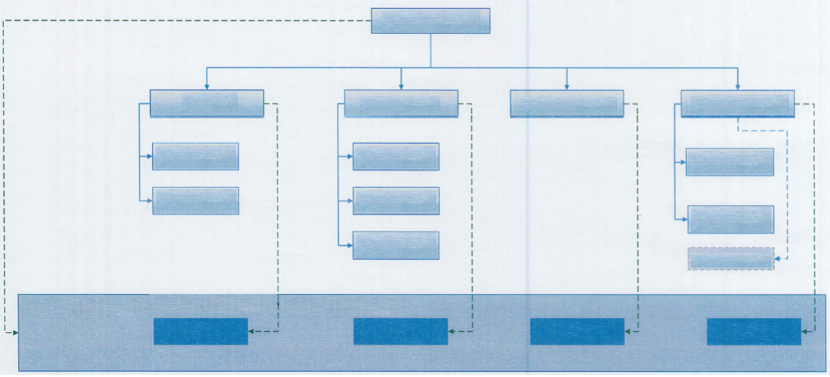

INVESTMENTS

HUMAN RESOURCES

PURCHASING

LEGAL

Processes under the operational coordination at the CNE Cernavoda and FCN Pitesti branches’ level

CTRF Group*

SERVICES AND WORKS PURCHASING SERVICE

(9/1/8)

U3 & U4 PROJECT DEPLOYMENT

DEPARTMENT

(2/1/1)

LITIGATION DEPARTMENT

(5/1/4)

DOCUMENTS LEGALITY ENDORSEMENT DEPARTMENT

(4/1/3)

PROJECTS MANAGEMENT DEPARTMENT

(4/1/3)

PRODUCTS PURCHASING SERVICE

(5/1/4)

PLANNING AND ELECTRONIC AUCTIONS SERVICE

(5/1/4)

INVESTMENTS

DEVELOPMENT DIVISION

(8/3/5)

HUMAN RESOURCES DEPARTMENT

(7/1/6)

PURCHASING DEPARTMENT

(20/4/16)

LEGAL DIVISION

(10/3/7)

DEPUTY GENERAL MANAGER

Mandate Ctr. –

(46/11/35)

|  |  |  |  |
| --- | --- | --- | --- |
| Administrative Subordination |  | **DEPUTY GENERAL MANAGER** | **CHIEF FINANCIAL OFFICER** |
| Functional Subordination |  | **DAN LAURENTIU TUDOR** | **ADRIAN DUMITRU** |
|  |  | *illegible signature* | *illegible signature* |
| Operational Coordination  inclusively by the subordinated  departments existing in the interface |  | **Head of the Strategic Planning** |  |
|  | **And Performance Analysis Department** |  |
|  | **Radu Gheorghiu Liviu Dumitru**  *Illegible signature* |  |

*) The CTRF Group is organized within the CNE Cernavoda Branch being administratively subordinated to the Branch Manager and

functionally subordinated to the Investments Development Division

2/7

*round stamp applied*

|  |  |  |  |  |
| --- | --- | --- | --- | --- |
|  | Societatea Nationala “Nuclearelectrica” S.A. |  | **ORGANISATION CHART**  **OF THE OPERATIONS DIVISION**  valid from *09.03.2020* | **APPROVED**  **PRESIDENT of the BD**  **Iulian Robert TUDORACHE**  *illegible signature* |
|  | **ENDORSED**  **GENERAL MANAGER**  **Cosmin GHITA**  *illegible signature* |

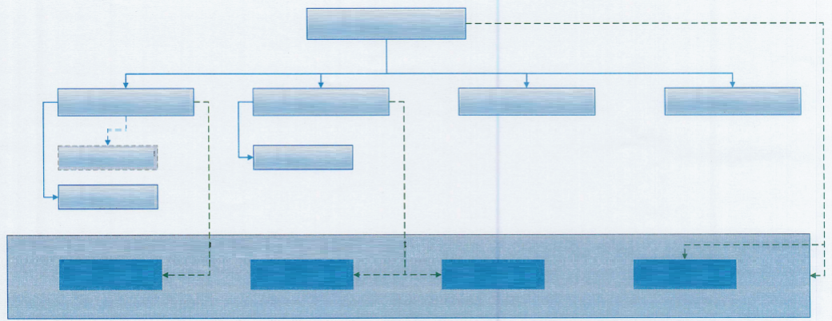

TECHNICAL SUPPORT SERVICE

(6/1/5)

PRODUCTION

NUCLEAR SECURITY

TECHNICAL

MODERNIZATION

Processes under the operational coordination at the CNE Cernavoda and FCN Pitesti branches’ level

EXTERNAL INTERFACE MODERNIZATION SERVICE

(4/1/3)

U1 CNE Cernavoda*

MODERNIZATION DEPARTMENT

STRATEGIC PLANNING AND PERFORMANCE ANALYSIS DEPARTMENT

(3/1/2)

DEVELOPMENT – INNOVATION SERVICE

(2/1/1)

NUCLEAR SECURITY AND TECHNICAL SUPPORT DEPARTMENT

(13/2/11)

MODERNIZATION DIVISION

(5/2/3)

OPERATIONS DIVISION

CHIEF OPERATIONS OFFICER (COO)

(25/7/18)

|  |  |  |  |  |
| --- | --- | --- | --- | --- |
| Administrative Subordination |  | **DEPUTY GENERAL MANAGER** | **CHIEF FINANCIAL OFFICER** | **CHIEF OPERATIONS OFFICER** |
| Functional Subordination |  | **DAN LAURENTIU TUDOR** | **ADRIAN DUMITRU** | **ROMEO URJAN** |
|  |  | *illegible signature* | *illegible signature* | *illegible signature* |
| Operational Coordination  inclusively by the subordinated  departments existing in the interface |  | **Head of the Strategic Planning** |  |  |
|  | **And Performance Analysis Department** |  |  |
|  | **Radu Gheorghiu Liviu Dumitru**  *Illegible signature* |  |  |

*) The u1 CNE Cernavoda Modernization Department is organized within the CNE Cernavoda being administratively

subordinated to the Branch Manager and functionally subordinated to the Modernization Division

3/7

*round stamp applied*

|  |  |  |  |  |
| --- | --- | --- | --- | --- |
|  | Societatea Nationala “Nuclearelectrica” S.A. |  | **ORGANISATION CHART**  **OF THE IT AND SECURITY OPERATIONS DIVISION**  valid from *09.03.2020* | **APPROVED**  **PRESIDENT of the BD**  **Iulian Robert TUDORACHE**  *illegible signature* |
|  | **ENDORSED**  **GENERAL MANAGER**  **Cosmin GHITA**  *illegible signature* |

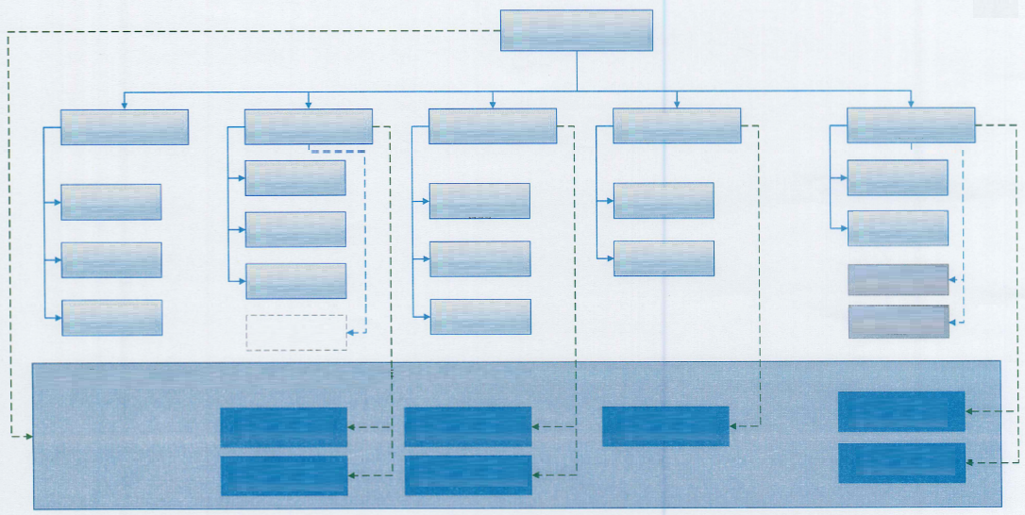

OT cyber security

(digital processes)

HW/SW/NW

INFRASTRUCTURE

Classified information

Physical protection

IT users support

IT cyber security

IT applications development

Processes under the operational coordination at the CNE Cernavoda and FCN Pitesti branches’ level

HARDWARE INFRASTRUCTURE SERVICE

(2/1/1)

CNE Cernavoda* Physical Protection and Classified Information Service

PHYSICAL PROTECTION AND HYBRID OFFICE

(7/1/6)

CLASSIFIED INFORMATION OFFICE

(2/1/1)

USERS SUPPORT SERVICE

(3/1/2)

IT AND OT PROTECTION TECHNOLOGIES SERVICE

(2/1/1)

HELP DESK/TICKETING OFFICE

(2/1/1)

IT/OT-SOC SECURITY OPERATIONS CENTER SERVICE

(2/1/1)

DevOPS** Team

FCN Pitesti* Physical Protection and Classified Information Service

SECURITY POLICY OFFICE

(1/1/0)

SOFTWARE AND DATA SERVICE

(6/1/5)

NETWORK SERVICE

(2/1/1)

IT PROJECTS OFFICE

(2/1/1)

SERVICE

(7/4/3)

IT SERVICES

SERVICE

(2/1/1)

IT SERVICES AND MANAGEMENT DEPARTMENT

(7/4/3)

PHYSICAL PROTECTION AND CLASSIFIED INFORMATION

(11/3/8)

IT SUPPORT DEPARTMENT

HELP DESK

(6/3/3)

IT & OT – CISO CYBER SECURITY DEPARTMENT

(6/4/2)

INFRASTRUCTURE DEPARTMENT

Hardware/Software/Network

(12/4/8)

IT AND SECURITY OPERATIONS DIVISION (CIO)

(47/19/28)

|  |  |  |  |  |
| --- | --- | --- | --- | --- |
| Administrative Subordination |  | **DEPUTY GENERAL MANAGER** | **CHIEF FINANCIAL OFFICER** | *) The Physical Protection and Classified Information Service is organized within the CNE Cernavoda branch and the Pitesti FCN branch being administratively subordinated to the branch Manager and functionally subordinated to the Physical Protection and Classified Information Department  **) The DEVOPS team is a team established by the General Manager’s decision consisting in IT specialists employed within the SNN, inclusively within the component branches, administratively subordinated to the organizational entity leader/coordinator which is part of and functionally subordinated for the development activities to the TeamLead within the HW/SW/NW Infrastructure Department |
| Functional Subordination |  | **DAN LAURENTIU TUDOR** | **ADRIAN DUMITRU** |
|  |  | *illegible signature* | *illegible signature* |
| Operational Coordination  inclusively by the subordinated  departments existing in the interface |  | **Head of the Strategic Planning** |  |
|  | **And Performance Analysis Department** |  |
|  | **Radu Gheorghiu Liviu Dumitru**  *Illegible signature* |  |

4/7

*round stamp applied*

|  |  |  |  |  |
| --- | --- | --- | --- | --- |
|  | Societatea Nationala “Nuclearelectrica” S.A. |  | **ORGANISATION CHART**  **AUDIT AND RISK MANAGEMENT DIVISION**  valid from *09.03.2020* | **APPROVED**  **PRESIDENT of the BD**  **Iulian Robert TUDORACHE**  *illegible signature* |
|  | **ENDORSED**  **GENERAL MANAGER**  **Cosmin GHITA**  *illegible signature* |

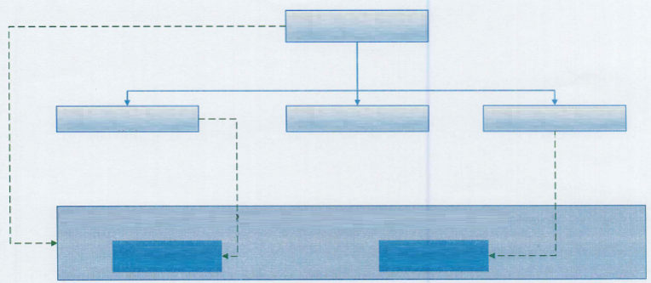

Risk Management

Internal Audit

Processes under the operational coordination at the CNE Cernavoda and FCN Pitesti branches’ level

RISK MANAGEMENT SERVICE

(3/1/2)

ANTI-FRAUD OFFICE

(1/1/0)

INTERNAL AUDIT

DEPARTMENT

(5/1/4)

AUDIT AND RISK MANAGEMENT DIVISION

DIVISION MANAGER

(10/4/6)

|  |  |  |  |  |
| --- | --- | --- | --- | --- |
| Administrative Subordination |  | **DEPUTY GENERAL MANAGER** | **CHIEF FINANCIAL OFFICER** | **AUDIT AND RISK MANAGEMENT**  **DIVISION MANAGER** |
|  |  | **DAN LAURENTIU TUDOR** | **ADRIAN DUMITRU** |
|  |  | *illegible signature* | *illegible signature* | **SANDULESCU MIHAI** |
| Operational Coordination  inclusively by the subordinated  departments existing in the interface |  | **Head of the Strategic Planning** |  |
|  | **And Performance Analysis Department** |  | *illegible signature* |
|  | **Radu Gheorghiu Liviu Dumitru**  *Illegible signature* |  |

5/7

*round stamp applied*

|  |  |  |  |  |
| --- | --- | --- | --- | --- |
|  | Societatea Nationala “Nuclearelectrica” S.A. |  | **ORGANISATION CHART**  **OF THE COMMUNICATION AND INVESTORS RELATION DEPARTMENT**  valid from *09.03.2020* | **APPROVED**  **PRESIDENT of the BD**  **Iulian Robert TUDORACHE**  *illegible signature* |
|  | **ENDORSED**  **GENERAL MANAGER**  **Cosmin GHITA**  *illegible signature* |

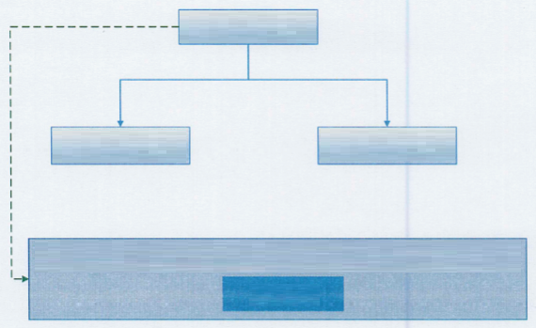

COMMUNICATION

Processes under the operational coordination at the CNE Cernavoda and FCN Pitesti branches’ level

CORPORATION EVENTS AND ADMINISTRATIVE SERVICE

(4/1/3)

INTERNAL, EXTERNAL AND CSR COMMUNICATION

(4/1/3)

COMMUNICATION AND INVESTORS RELATIONS DEPARTMENT

(9/3/6)

|  |  |  |  |
| --- | --- | --- | --- |
| Administrative Subordination |  | **DEPUTY GENERAL MANAGER** | **CHIEF FINANCIAL OFFICER** |
|  |  | **DAN LAURENTIU TUDOR** | **ADRIAN DUMITRU** |
|  |  | *illegible signature* | *illegible signature* |
| Operational Coordination  inclusively by the subordinated  departments existing in the interface |  | **Head of the Strategic Planning** |  |
|  | **And Performance Analysis Department** |  |
|  | **Radu Gheorghiu Liviu Dumitru**  *Illegible signature* |  |

6/7

*round stamp applied*

|  |  |  |  |  |
| --- | --- | --- | --- | --- |
|  | Societatea Nationala “Nuclearelectrica” S.A. |  | **ORGANISATION CHART**  **CHIEF FINANCIAL OFFICER**  valid from *09.03.2020* | **APPROVED**  **PRESIDENT of the BD**  **Iulian Robert TUDORACHE**  *illegible signature* |
|  | **ENDORSED**  **GENERAL MANAGER**  **Cosmin GHITA**  *illegible signature* |

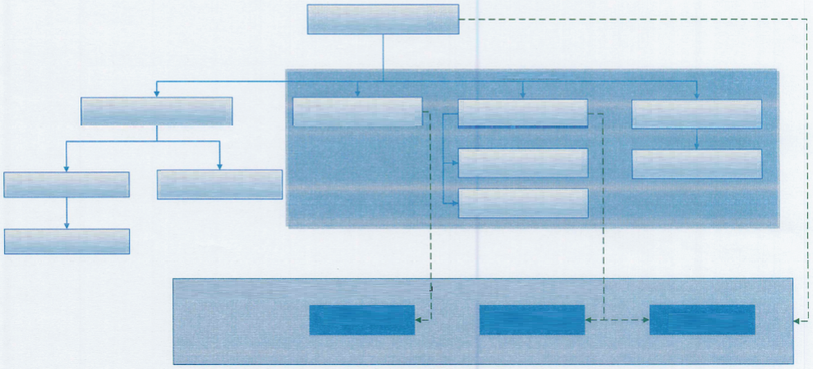

NOTIFICATIONS AND REPORTS SERVICE

(4/1/3)

CONTRACTS AND REGULATIONS DEPARTMENT

(4/1/3)

TRADING AND REPORTS DEPARTMENT

(6/2/4)

Financial Division

Processes under the operational coordination at the CNE Cernavoda and FCN Pitesti branches’ level

Patrimony

Financial - Accountancy

Cost – Budget Analyses

ACCOUNTING SERVICE

(5/1/4)

ARCHIVE OFFICE

(1/0/1)

FINANCIAL SERVICE

(8/1/7)

ADMINISTRATIVE SERVICE

(12/1/11)

FINANCIAL AND ACCOUNTING DEPARTMENT

(14/3/11)

FINANCIAL AND ACCOUNTING DEPARTMENT

(14/3/11)

ELECTRIC POWER TRANSACTIONS DIVISION

(12/4/8)

CHIEF FINANCIAL OFFICER

Mandate Ctr. –

(42/9/33)

|  |  |  |  |
| --- | --- | --- | --- |
| Administrative Subordination |  | **DEPUTY GENERAL MANAGER** | **CHIEF FINANCIAL OFFICER** |
|  |  | **DAN LAURENTIU TUDOR** | **ADRIAN DUMITRU** |
|  |  | *illegible signature* | *illegible signature* |
| Operational Coordination  inclusively by the subordinated  departments existing in the interface |  | **Head of the Strategic Planning** |  |
|  | **And Performance Analysis Department** |  |
|  | **Radu Gheorghiu Liviu Dumitru**  *Illegible signature* |  |

7/7